Cadorna, Joeffrey 6/29/2026
BSCS – 2 (CBM)
- Array in PHP
Act 1: Server Info & Database Connection
Source Code
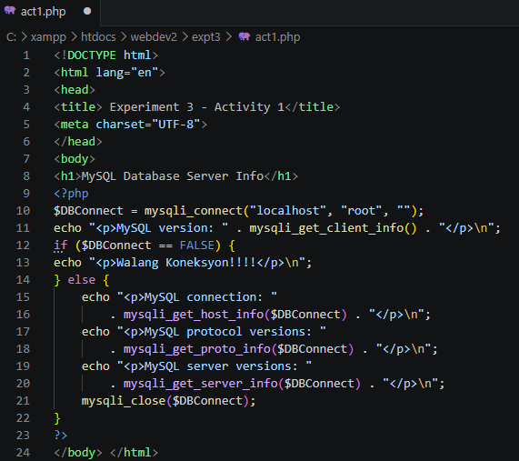
Browser Output
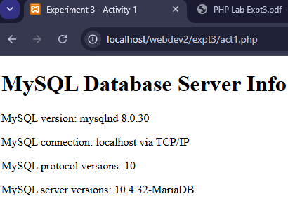

Act 2 A: Create Database using code
Source Code
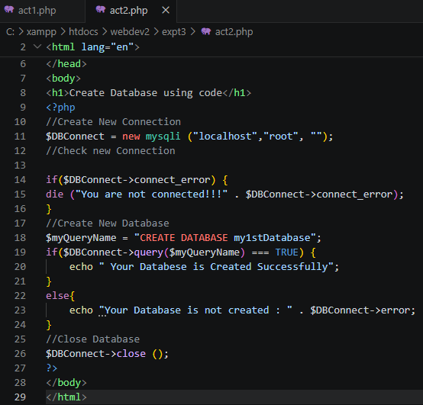
Browser Output
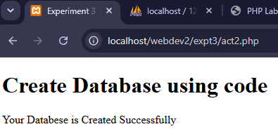

SQL
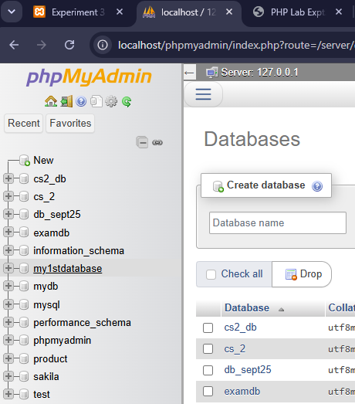

Act 2 B: Create Database using the browser
SQL
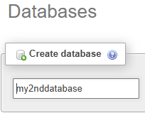
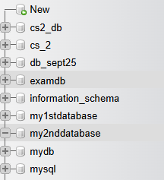

Act 3 A: Create Table using code
Source Code
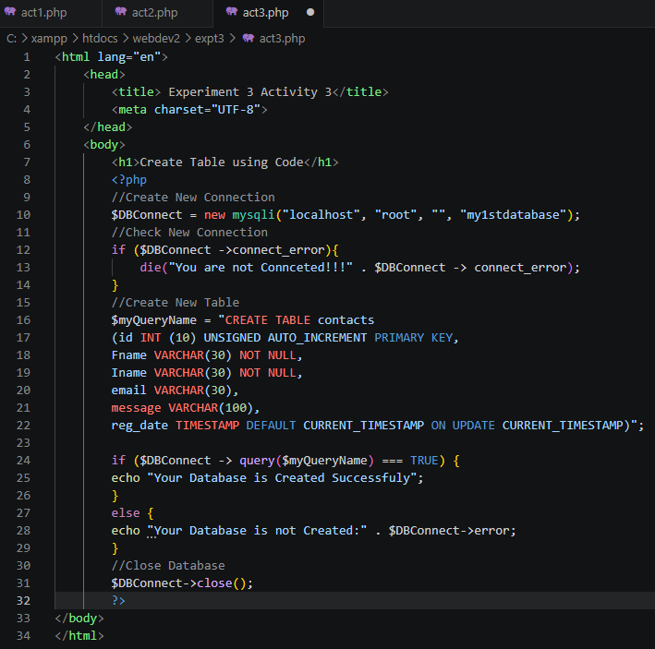
Browser Output
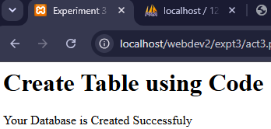
SQL
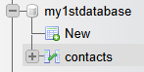
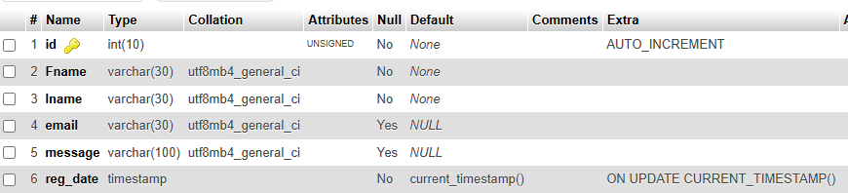
Act 3 B: Create Table using the browser
SQL
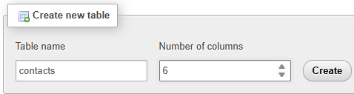
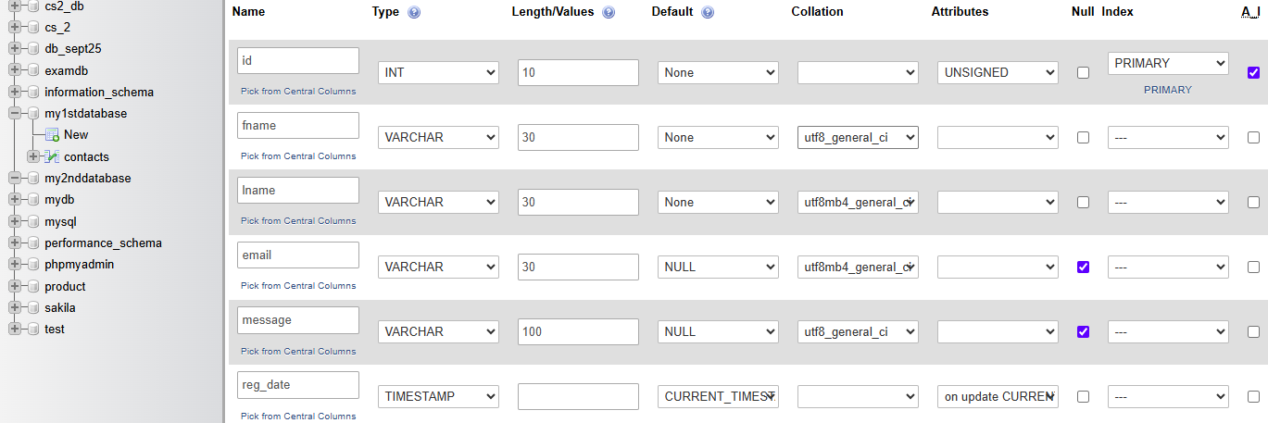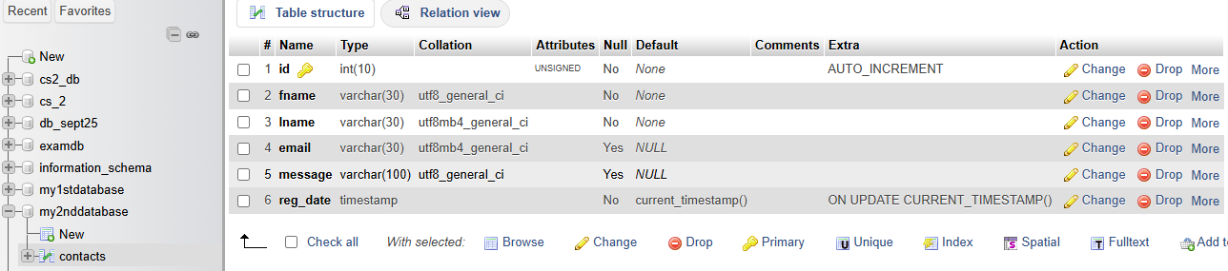

Act 4: PHP Contact form with MySQL
Source Code
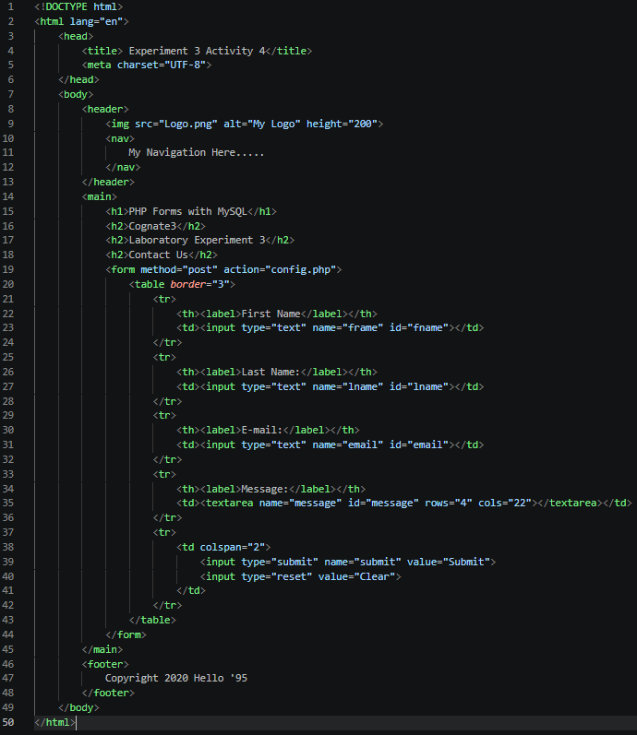

Browser Output
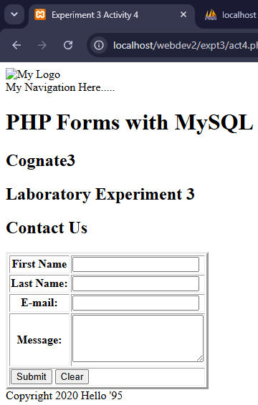

Act 4: thank you
Source Code
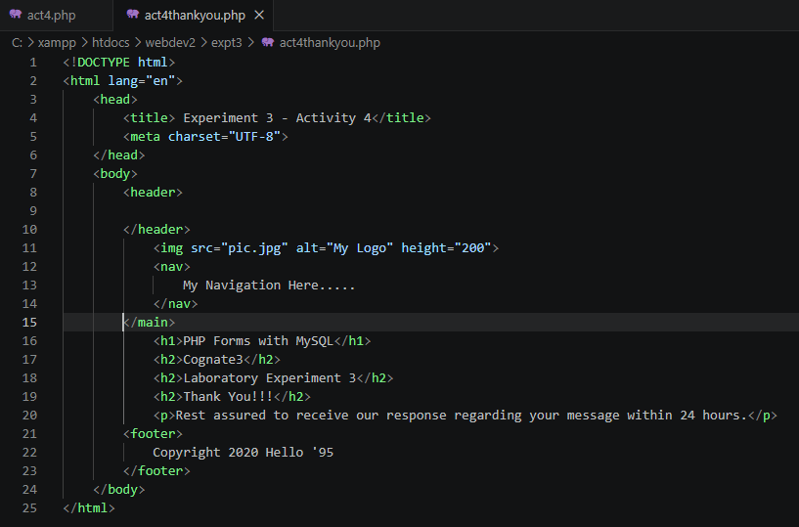

Act 4: config
Source Code
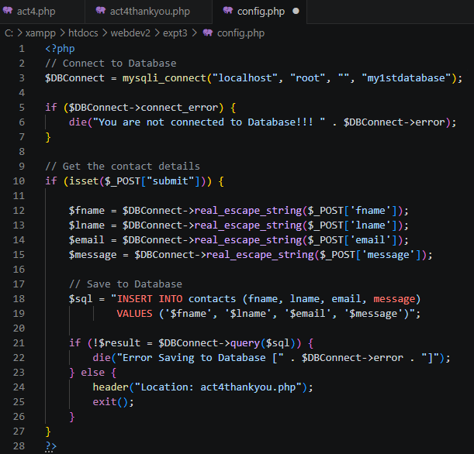
Browser Output
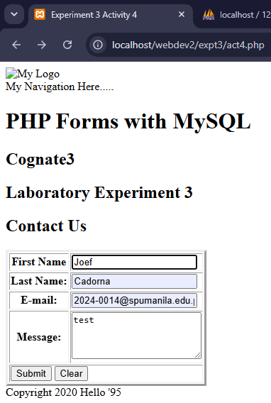
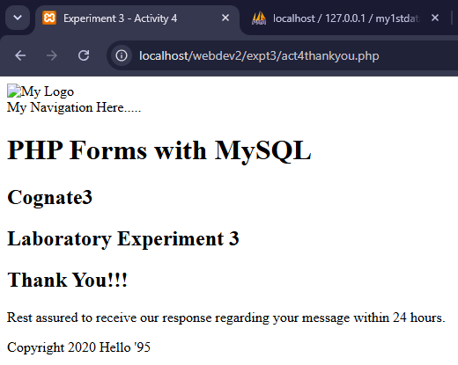
SQL
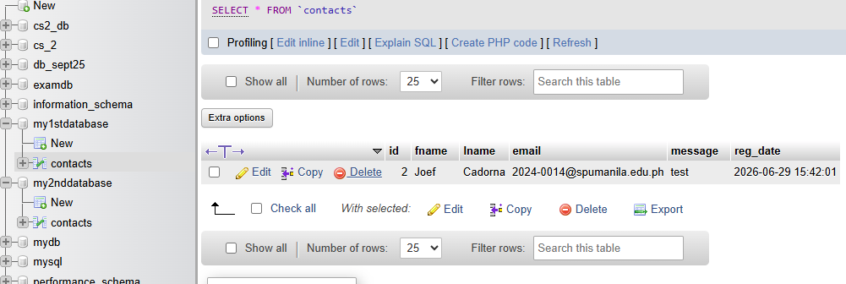

B. Answer the following question:

1. Discuss the following types of Database
Flat Database: A flat database stores all data in a single table or file with rows and columns. It is simple to create but becomes inefficient for large or complex data relationships. While Hierarchical Database organizes data in a tree-like structure using parent-child relationships. Each child record is connected to only one parent, making data retrieval structured but less flexible. On the other hand, Relational Database, it stores data in multiple related tables using keys (using the primary and foreign keys). It is widely used because it supports efficient querying, organization, and data integrity.

2. What is Normalization of Data?
Normalization is the process of organizing data in a database to reduce redundancy and improve consistency. It divides data into related tables and establishes relationships to maintain accuracy and efficiency.

3. Research about NoSQL Movement
The NoSQL Movement refers to the development and adoption of non-relational databases designed to handle large volumes of data, fast processing, and flexible data structures. NoSQL databases include document, key-value, column, and graph databases and are commonly used in web applications and cloud computing.

4. Research about BIG DATA
Big Data refers to extremely large and complex datasets that cannot be efficiently processed using traditional database systems. It is characterized by the 5 Vs: Volume (amount of data), Velocity (speed), Variety (different formats), Veracity (accuracy), and Value (usefulness). Big Data is used in analytics, business intelligence, healthcare, finance, and technology.

